Social Emotional Learning
[Name]
[Institution Affiliation]
[Course]
[Date]

SOCIAL-EMOTIONAL LEARNING (SEL)
Social-emotional learning can be described as a process whereby youngsters and adults acquire and effectively utilize knowledge, attitudes, and skills that are essential in understanding and managing emotions, setting and achieving positive goals, feeling and demonstrating empathy towards other people, establishing and keeping positive relationships, and making responsible decisions. Social-emotional learning is usually applied as a systematic framework in various ways. It is applied as a correlating framework regarding the manner in which instructors, households, and societies join hands to enhance the social, emotional, and academic learning of students (Denham et al., 2014). Such stakeholders ensure that SEL is incorporated into their strategic planning, staffing, professional education, as well as the budgets.
The aforementioned framework offers guidelines for the curriculum options and instructions provided in the classrooms. These include the direct application of SEL and an integrated approach in subjects like mathematics, history, and reading among other major areas of study (Elias et al., 2014). The framework aids in managing most of the schoolwide approaches and policies. It covers on the approach in which students and adults relate with one another in every level of the system, promoting a conducive, participatory, and hospitable learning climate. It is essential for shaping their relationships with families and members of the community by enhancing engagement, partnership, and trust.
There are five core competencies which are applied to various settings. Their main objective is to educate hearts, be an inspiration to the minds as well as assisting people to effectively navigate the world. The teaching contexts and the overall academic environment are also significant aspects which influence the success of the SELL competencies. Thus, SEL is an integrated teaching approach which encompasses coordinated efforts across the various school, home, community, district, and classroom environments (Espelage et al., 2015).
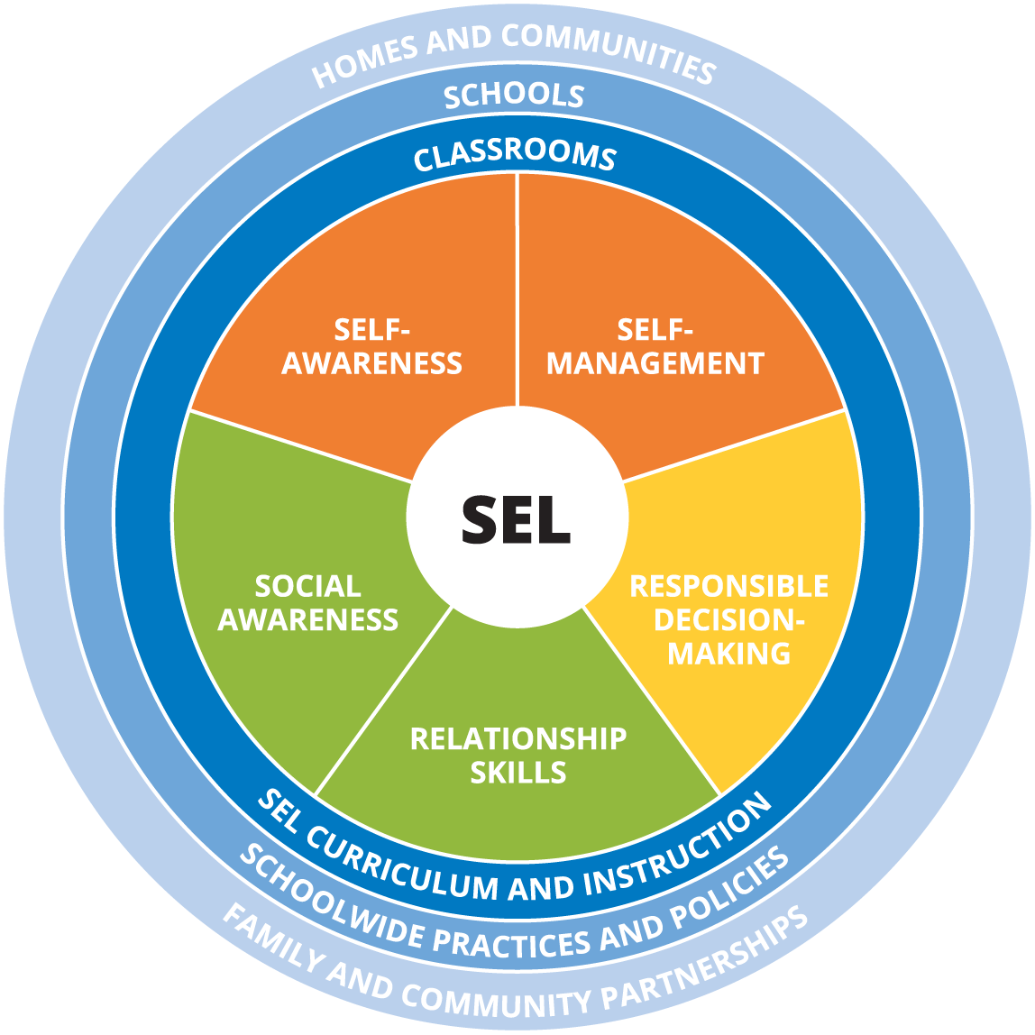
Source: (CASEL, 2017).
Self-management refers to the ability to successfully control an individual’s feelings, thoughts, and behaviors in various contexts. It may encompass effective stress management, impulse management, personal discipline, personal motivation, the setting of objectives, and organizational skills. Self-awareness is the capacity to appropriately recognize personal emotions and thoughts as well as the manner in which such factors affect behavior. It involves the assessment of an individual’s strengths and weaknesses by applying an appropriate sense of conviction, optimism, and a growth-oriented mindset (Jones et al., 2014). It may involve identification of emotions, appropriate self-perception, recognition of strengths, self-conviction, as well as self-efficacy. Social awareness implies to the capability to assume the perspective of and demonstrate empathy for other people and even individuals hailing from diversified backgrounds and cultures. It consists of assuming the perspective of another person, demonstrating empathy, embracing diversity, and respecting other people.
The relationship skills refer to the potential regarding the establishment and maintenance of healthy and beneficial relationships with diversified groups and persons. It may particularly indicate the capability to communicate effectively, have good listening skills, cooperate with other people, resist improper social issues, constructive negotiation of conflicts as well as to look for and provide necessary assistance. The major aspects involved consist of communication, social involvement, the building of relationships and working as a team (Schonfeld et al., 2015). On the other hand, responsible decision-making implies to the capacity to come up with constructive options regarding individual conduct and socialization on the basis of ethical standards, safety measures, and social standards. It may require the actual evaluation of the repercussions of several actions as well as consider personal and societal well-being. The major aspects may comprise of problem identification, situation analysis, problem-solving, evaluation, reflection, and ethical responsibility.
An effective SEL approach should take into consideration several aspects abbreviated as SAFE. The aspects include Sequenced, Active, Focused, and Explicit. The aspect of “Sequenced” refers to the related and organized activities aimed at promoting the development of skills. The “Active” element implies to the active learning methods designed to assist students to maintain newly acquired abilities and attitudes. On the other hand, “Focused” is a factor that highlights the development of individual and social skills. Lastly “Explicit” implies to the trait of focusing on particular social and emotional abilities (Weissberg et al., 2013). However, learning institutions apply SAFE approaches to enhance the social and emotional growth of the learners. Examples include that modeling and coaching methods may be applied on teaching process to enable students to acknowledge their emotions or recognize the feelings of others. The students may also utilize class meetings to exercise decision-making as a group or set rules to be applied in the classroom context.
Emotional intelligence is the capability to recognize and acknowledge personal emotions and the emotions of other individuals as well as the capacity to manage emotions. People who have a high degree of emotional intelligence are presumed to have the best social relations, increased ability and speed of solving emotional issues, demonstrate stability in verbal, social, and various forms of intelligence, is less likely to portray problematic traits, and are able to escape self-destruction behavior such as the use of drugs. Emotional intelligence is beneficial to people in various ways including physical well-being, mental health, social relations, resolution of conflicts, success as well as leadership capabilities. On the other hand, social skills are the capabilities that enhance interaction and communication of an individual with other people through the creation of social rules and relations are formed, communicated, and altered through verbal and non-verbal mechanisms (Poulou, 2014). Some social skills may include communication and interaction of individuals through body language, gestures or personal appearance. They comprise of both verbal and non-verbal abilities of a person.
The emotional intelligence and social skills are significant aspects of special education, particularly for kids experiencing a mental delay. This may apply to students who may not be deprived of emotions and have the potential to empathize. Students experiencing mental delay may be taken through training on emotional intelligence and social skills. The reason is that, such training help in boosting their communication skills. Several research works indicate that there exists a possibility of a correlation between emotional intelligence and communication capabilities. The implication is that an individual who has the capacity to understand the changes in the moods of other people are certainly in a position to manage and regulate their personal feelings and those of others as well (Ciarrochi & Mayer, 2013). Previous studies also indicate that there is a substantial relationship between most of the factors of emotional intelligence and interpersonal issues. Various constituents of emotional intelligence may be able to predict some factors of interpersonal challenges. The implication is that, when emotional intelligence was combined with supports on mental health, the act minimized interpersonal issues and promoted the state of social and interpersonal connections. It could also enhance the capacity to acknowledge facial expressions and the emotional reactions towards such expressions and feelings. Such skills may be experienced at lower levels in kids with mental delay condition.
Moreover, previous studies indicate that emotional intelligence training could be applied to treat issues regarding emotional recognition in children experiencing some mental delay. The training on emotional intelligence offers training to the students concerning the development of effective communication skills. The training on emotional intelligence and social skills is significant to special education since it helps the kids with the mental delay condition to communicate with their colleagues and other people with minimal challenges (Poulou, 2014). During the training sessions, the students have the opportunity to perform an evaluation of their abilities by use of activities like role-playing and various games. The exercise may also include the utilization of flashcards that are designed to educate them on such skills and improve on the level of interaction among them. Previous researchers have established that training on emotional intelligence can be applied to promote the communicative functions of children through equipping them with interpersonal knowledge, social skills, and a basic understanding of the constituents of verbal and non-verbal communication.
The intervention procedure regarding emotional intelligence was specifically created to assist students experiencing some mental delay to handle their issues and allow them to deal with the challenges linked to mental delay. The process would also help such students to perform their tasks effectively and improve their flexibility. The implication is that the right perception of emotions of an individual and others helps in promoting interpersonal communication, emphasizing protection, emotions, and looking for help from others hence promoting mental health. Previous research has also indicated that several social cognitive difficulties emanate from failure to understand complex emotions expressed by others which may demand an inference on the mental state of an individual. Such complex emotional expressions may include pride, irritation, verbal and non-verbal emotional reactions (Ciarrochi & Mayer, 2013). Thus, training programs on emotional intelligence play a significant role in boosting communication abilities among students with mental delay.

References
Ciarrochi, J., & Mayer, J. D. (2013). Applying emotional intelligence: A practitioner's guide. Psychology Press.
Denham, S. A., Bassett, H. H., Zinsser, K., & Wyatt, T. M. (2014). How preschoolers' social–emotional learning predicts their early school success: Developing theory‐promoting, competency‐based assessments. Infant and Child Development, 23(4), 426-454.
Elias, M. J., & Schwab, Y. (2014). From Compliance to Responsibility: Social-Emotional Learning and Classroom Management. In Handbook of classroom management (pp. 104-125). Routledge.
Espelage, D. L., Rose, C. A., & Polanin, J. R. (2015). Social-emotional learning program to reduce bullying, fighting, and victimization among middle school students with disabilities. Remedial and special education, 36(5), 299-311.
Jones, S. M., Bailey, R., & Jacob, R. (2014). Social-emotional learning is essential to classroom management. Phi Delta Kappan, 96(2), 19-24.
Poulou, M. S. (2014). How are trait emotional intelligence and social skills related to emotional and behavioural difficulties in adolescents?. Educational Psychology, 34(3), 354-366.
Schonfeld, D. J., Adams, R. E., Fredstrom, B. K., Weissberg, R. P., Gilman, R., Voyce, C., ... & Speese-Linehan, D. (2015). Cluster-randomized trial demonstrating impact on academic achievement of elementary social-emotional learning. School Psychology Quarterly, 30(3), 406.
Weissberg, R. P., & Cascarino, J. (2013). Academic learning+ social-emotional learning= national priority. Phi Delta Kappan, 95(2), 8-13.
Weissberg, R. P., Durlak, J. A., Domitrovich, C. E., & Gullotta, T. P. (2015). Social and emotional learning: Past, present, and future.
Yoder, N. (2014). Teaching the whole child: Instructional practices that support social-emotional learning in three teacher evaluation frameworks. Washington, DC: American Institutes for Research Center on Great Teachers and Leaders.

